TM200 HSC.VD method of application

The HSC channel connected ABZ 3 phase encoder, HSC value is cleared by z-phase pulse, then compared the current value of the HSC ， occasionally the current value was less than 50 , and the %M140 was set to true. I used TM241PTO channel to send fixed frequency pulse for experiment.
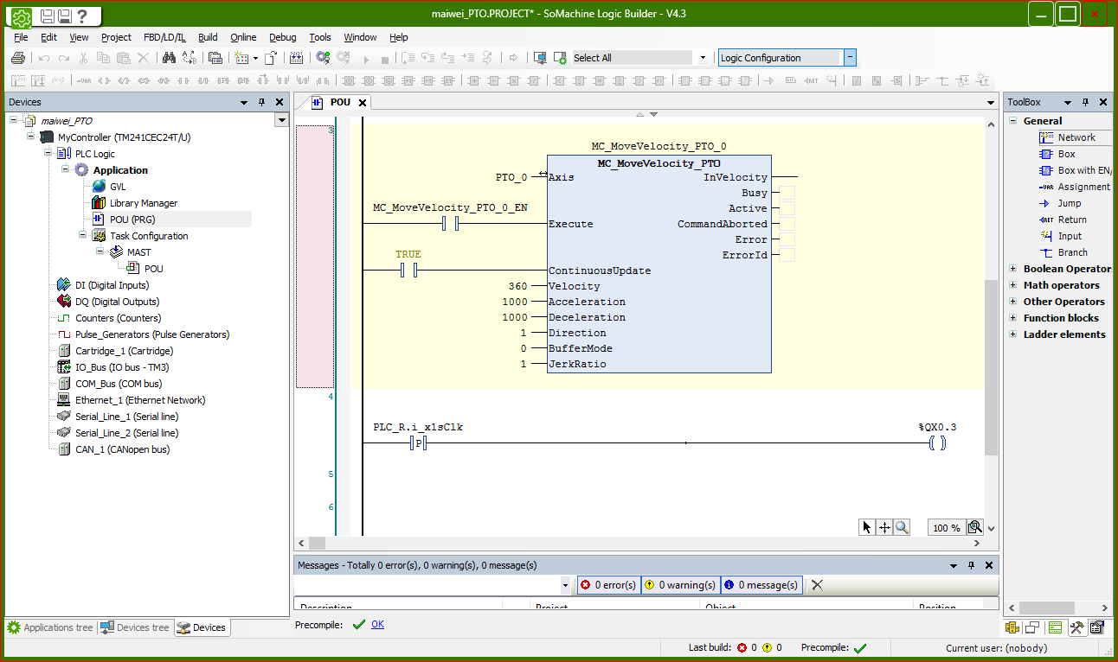
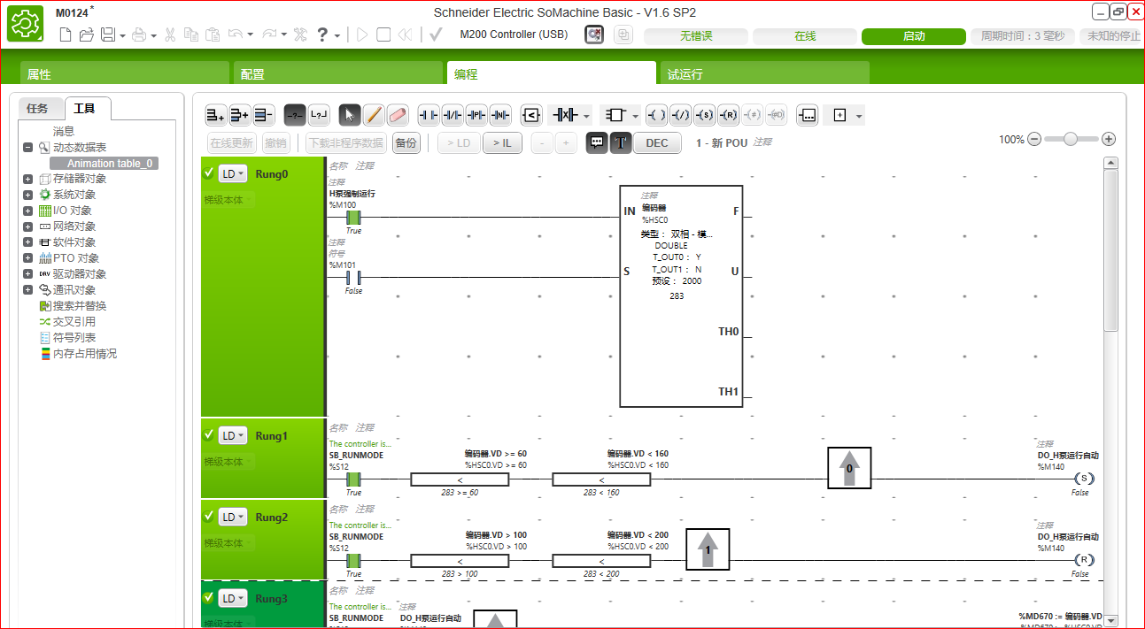

When 60<=HSC0.VD<100,M140 is set; when 100<HSC0.VD<200,M140 is reset.
The following program RUING1,2,3 can see that M140 can only be set in hsc0.vd between 60 and 100. When M140 is set, the count value of hsc0.vd is read and maintained to MD670. In the comparison program RUING3, it can be found that MD670 is compared with 50.
The problem is that hsc0.vd is between 60 and 100. M140 will be set, and the value of MD670 is also between 60 and 100. It cannot be less than 50, but in fact it is less than 50.
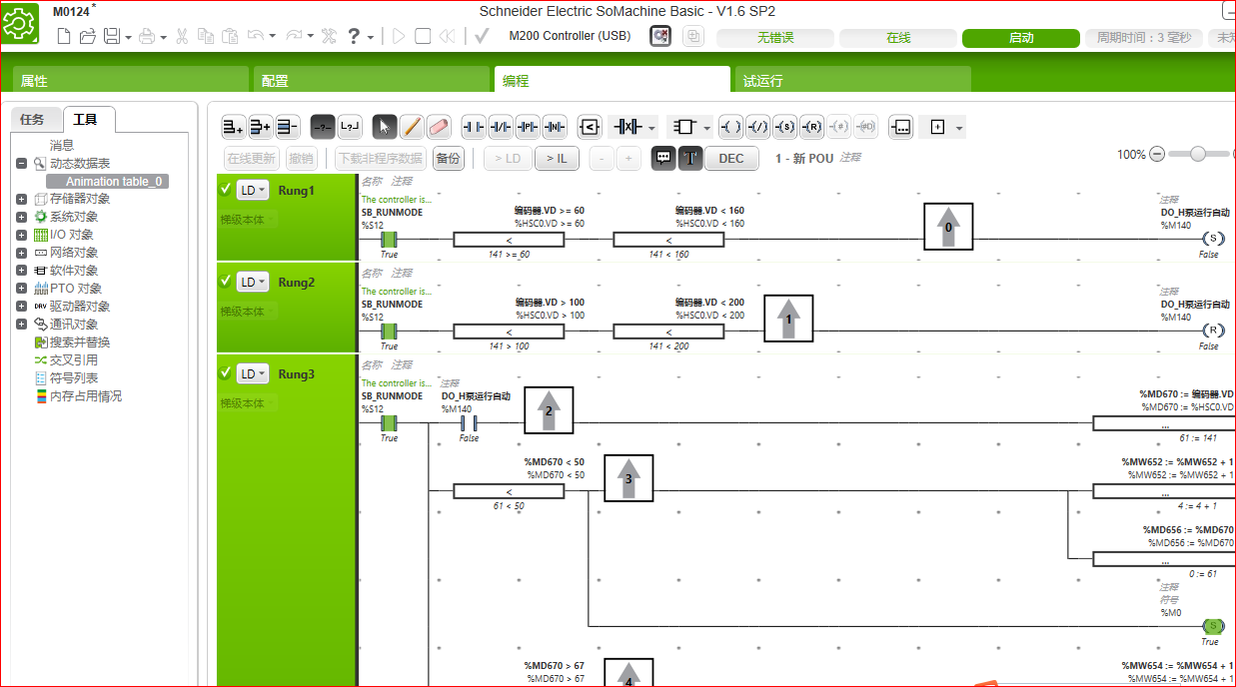

Solution: The HSC.VD register value assigns the %MD register, and then uses %MD to compare the %M140 will not output by mistake.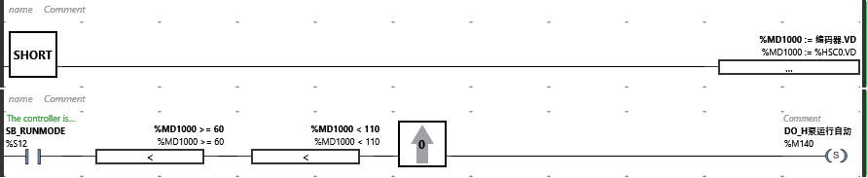

When HSCVD is called in the program for comparison, the %m140 in the program is set and cannot be performed according to the comparison condition in the program. For future users to use HCSVD correctly, the use of high-speed counter can be explained in the online help

